DOKUMENTASI UAS

MATA KULIAH PL/SQL

Disusun Oleh:

Nama :Tyan Nur Khollis

NIM : 41520010057

Jurusan : Teknik Informatika

Dosen pengampu : Nur Azis, S.Kom, M.Kom

**Soal UAS** **:**

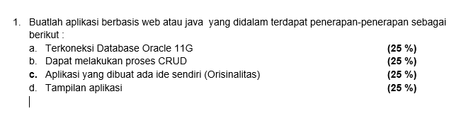

**Source Code bahasa PHP untuk mengkoneksikan web server dengan database oracle :**

<?php

$conn = oci_connect('tyan','oracle','localhost/XE');

?>

Menggunakan fungsi oci_connect yang berisi parameter : schema, password, dan database

**Tampilan Halaman Indeks / Utama :**

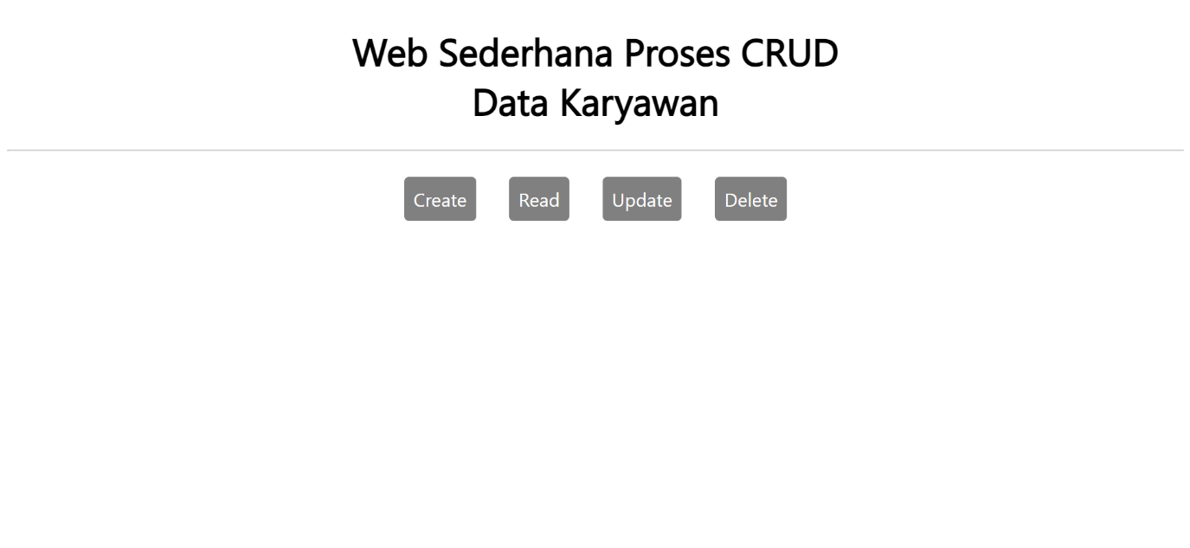

**Source Code PHP Halaman Indeks / Utama :**

<!DOCTYPE html>

<html lang="en">

<head>

<meta charset="UTF-8">

<meta name="viewport" content="width=device-width, initial-scale=1.0">

<title>CRUD Sederhana</title>

<link rel="stylesheet" href="styles.css">

</head>

<body>

<h1>Web Sederhana Proses CRUD <br> Data Karyawan </h1>

<hr><br>

<div class="nav">

<a href="create.php" title = "Menambah Data Karyawan">Create</a>

<a href="read.php" title = "Menampilkan Data Karyawan">Read</a>

<a href="update.php" title = "Mengubah Data Karyawan">Update</a>

<a href="delete.php" title = "Hapus Data Karyawan">Delete</a>

</div>

</body>

</html>

**Tampilan Halaman Create :**

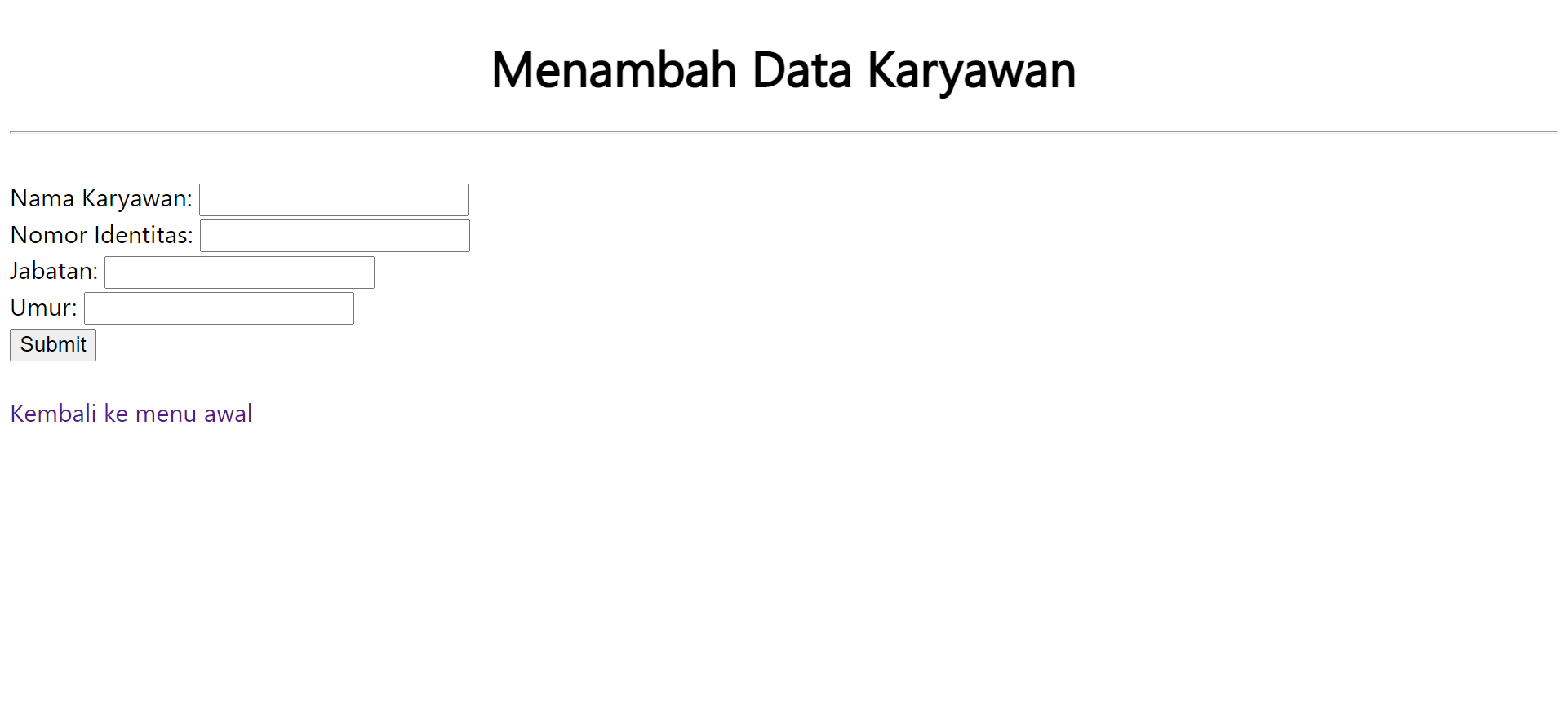

**Source Code PHP Halaman Create :**

<!DOCTYPE html>

<html lang="en">

<head>

<meta charset="UTF-8">

<meta name="viewport" content="width=device-width, initial-scale=1.0">

<title>Menambah Data</title>

<link rel="stylesheet" href="styles.css">

</head>

<body>

<h1>Menambah Data Karyawan</h1>

<hr><br>

<form action="" method="post">

<label for="nama">Nama Karyawan:</label>

<input type="text" id="nama" name="nama"><br>

<label for="nomor_id">Nomor Identitas:</label>

<input type="text" id="nomor_id" name="nomor_id"><br>

<label for="jabatan">Jabatan:</label>

<input type="text" id="jabatan" name="jabatan"><br>

<label for="umur">Umur:</label>

<input type="text" id="umur" name="umur"><br>

<input type="submit" value="Submit" name="Submit">

</form>

<br>

<a style="text-decoration:none;"href="index.php">Kembali ke menu awal</a>

</body>

</html>

<?php

require "koneksi.php";

if(isset($_POST['Submit'])){

$nama = $_POST['nama'];

$nomor_id = $_POST['nomor_id'];

$jabatan = $_POST['jabatan'];

$umur = $_POST['umur'];

$insert = oci_parse($conn, "INSERT INTO KARYAWAN VALUES('$nama', '$nomor_id', '$jabatan', '$umur')");

oci_execute($insert);

echo "</br> Berhasil Menambah Data Karyawan";

}

?>

**Tampilan Halaman Read :**

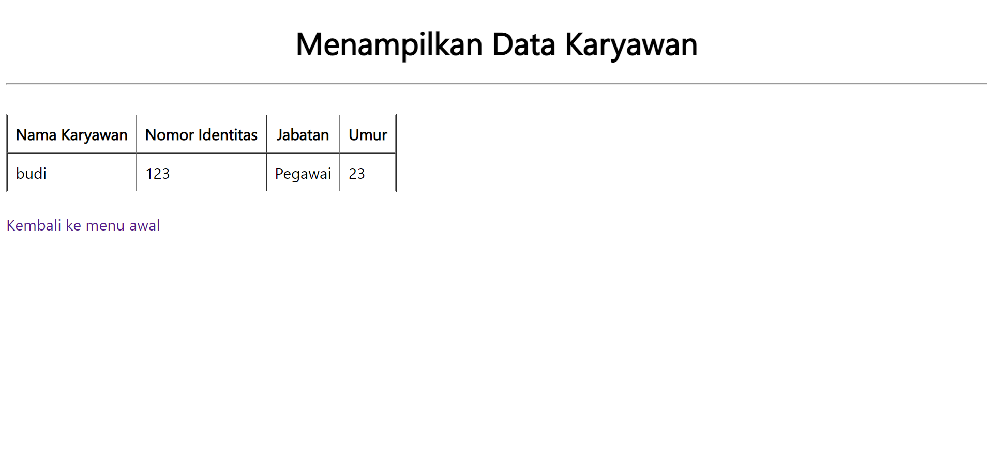

**Source Code PHP Halaman Read :**

<?php

include "koneksi.php"

?>

<!DOCTYPE html>

<html lang="en">

<head>

<meta charset="UTF-8">

<meta name="viewport" content="width=device-width, initial-scale=1.0">

<title>Menampilkan Data</title>

<link rel="stylesheet" href="styles.css">

</head>

<body>

<h1>Menampilkan Data Karyawan</h1>

<hr><br>

<table border="1" cellpadding="10" cellspacing="0">

<tr>

<th>Nama Karyawan</th>

<th>Nomor Identitas</th>

<th>Jabatan</th>

<th>Umur</th>

</tr>

<?php

$query = oci_parse($conn, "SELECT * FROM KARYAWAN");

oci_execute($query);

while($rows = oci_fetch_array($query)){ ?>

<tr class="data">

<td><?=$rows['NAMA_KARYAWAN'] ?></td>

<td><?=$rows['NOMOR_ID'] ?></td>

<td><?=$rows['JABATAN'] ?></td>

<td><?=$rows['UMUR'] ?></td>

</tr>

<?php } ?>

</table>

<br>

<a style="text-decoration:none; "href="index.php">Kembali ke menu awal</a>

</body>

</html>

**Tampilan Halaman Update :**

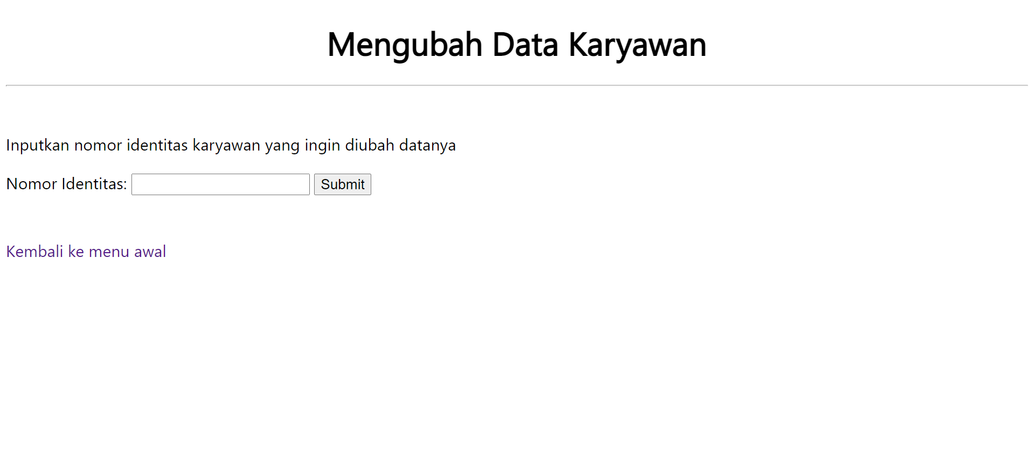

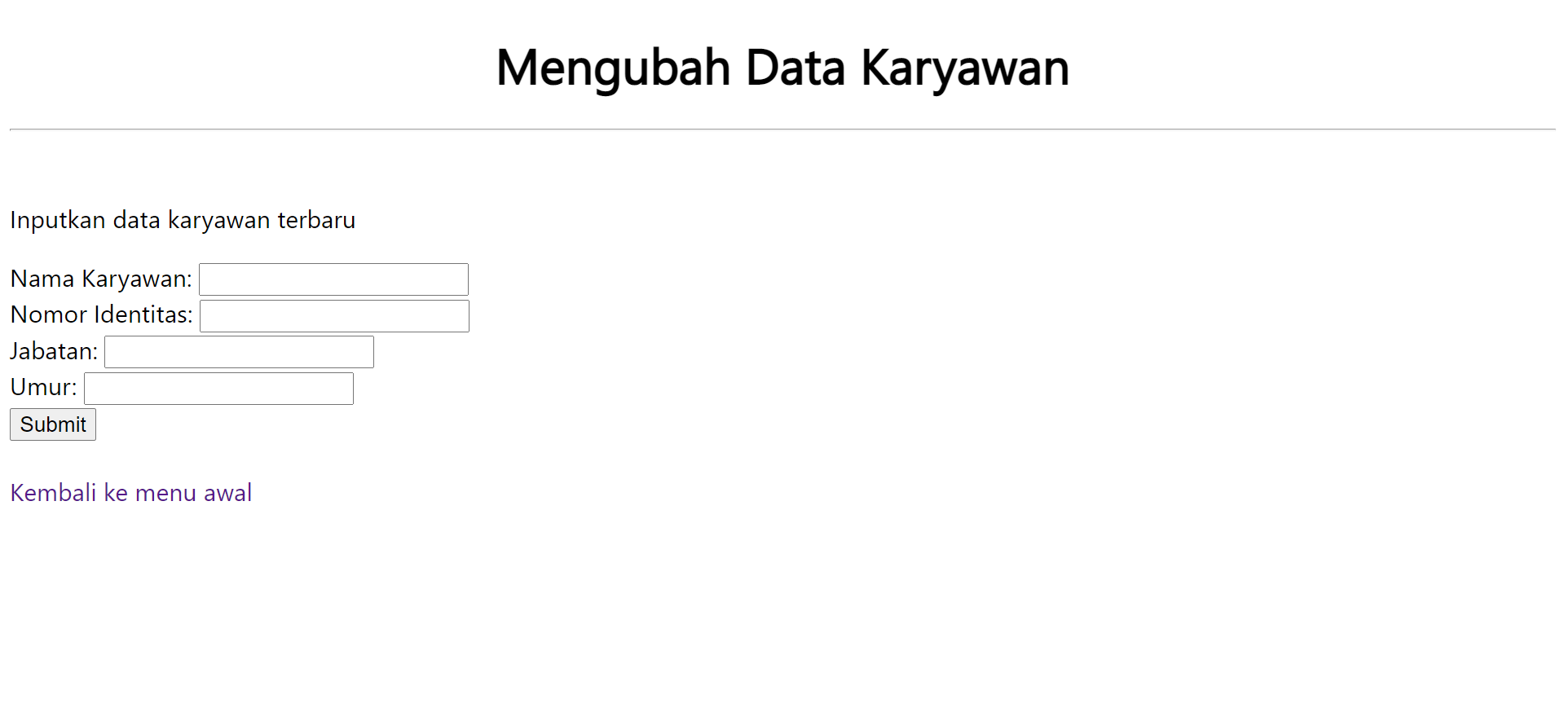

**Source Code PHP Halaman Update :**

<!DOCTYPE html>

<html lang="en">

<head>

<meta charset="UTF-8">

<meta name="viewport" content="width=device-width, initial-scale=1.0">

<title>Mengubah Data</title>

<link rel="stylesheet" href="styles.css">

</head>

<body>

<h1>Mengubah Data Karyawan</h1>

<hr><br>

<p>Inputkan nomor identitas karyawan yang ingin diubah datanya</p>

<form action="update2.php" method="get">

<label for="no_id">Nomor Identitas:</label>

<input type="text" id="no_id" name="no_id">

<input type="submit" value="Submit" name="submit">

</form>

<br><br>

<a style="text-decoration:none; "href="index.php">Kembali ke menu awal</a>

</body>

</html>

<!DOCTYPE html>

<html lang="en">

<head>

<meta charset="UTF-8">

<meta name="viewport" content="width=device-width, initial-scale=1.0">

<title>Mengubah Data</title>

<link rel="stylesheet" href="styles.css">

</head>

<body>

<?php

require "koneksi.php";

$no_id = $_GET['no_id']; ?>

<h1>Mengubah Data Karyawan</h1>

<hr><br>

<p>Inputkan data karyawan terbaru</p>

<form action="" method="post">

<label for="nama">Nama Karyawan:</label>

<input type="text" id="nama" name="nama"><br>

<label for="nomor_id">Nomor Identitas:</label>

<input type="text" id="nomor_id" name="nomor_id"><br>

<label for="jabatan">Jabatan:</label>

<input type="text" id="jabatan" name="jabatan"><br>

<label for="umur">Umur:</label>

<input type="text" id="umur" name="umur"><br>

<input type="submit" value="Submit" name="Submit">

</form>

<?php

if(isset($_POST['Submit'])){

$nama = $_POST['nama'];

$nomor_id = $_POST['nomor_id'];

$jabatan = $_POST['jabatan'];

$umur = $_POST['umur'];

$query = oci_parse($conn,"UPDATE KARYAWAN SET NAMA_KARYAWAN='$nama', NOMOR_ID='$nomor_id', JABATAN='$jabatan', UMUR='$umur' WHERE NOMOR_ID='$no_id'");

oci_execute($query);

echo "Data berhasil diubah";

}

?>

<br>

<a style="text-decoration:none; "href="index.php">Kembali ke menu awal</a>

</body>

</html>

**Tampilan Halaman Delete:**

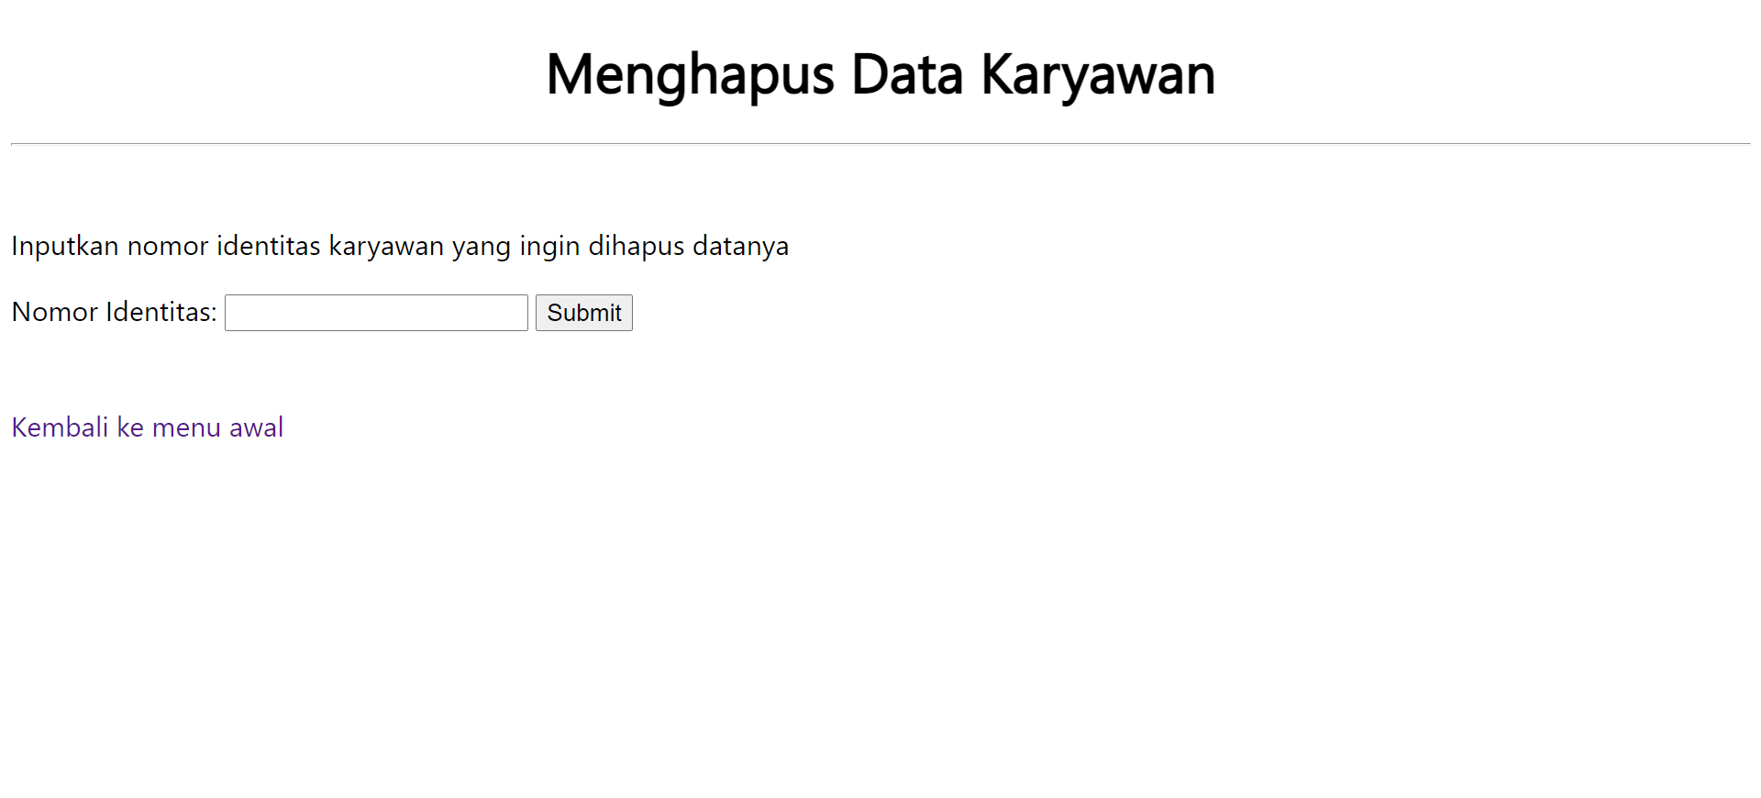

**Source Code PHP Halaman Delete :**

<!DOCTYPE html>

<html lang="en">

<head>

<meta charset="UTF-8">

<meta name="viewport" content="width=device-width, initial-scale=1.0">

<title>Mengubah Data</title>

<link rel="stylesheet" href="styles.css">

</head>

<body>

<h1>Menghapus Data Karyawan</h1>

<hr><br>

<p>Inputkan nomor identitas karyawan yang ingin dihapus datanya</p>

<form action="" method="get">

<label for="no_id">Nomor Identitas:</label>

<input type="text" id="no_id" name="no_id">

<input type="submit" value="Submit" name="submit">

</form>

<?php

require "koneksi.php";

if(isset($_GET['submit'])){

$no_id = $_GET['no_id'];

$query = oci_parse($conn, "DELETE FROM KARYAWAN WHERE NOMOR_ID='$no_id'");

oci_execute($query);

echo "Data Berhasil Dihapus";

}

?>

<br><br>

<a style="text-decoration:none; "href="index.php">Kembali ke menu awal</a>

</body>

</html>

**Source Code CSS :**

.nav {

text-align: center;

}

.nav a{

background-color: grey;

padding: 10px;

margin: 15px;

border-radius: 5px;

color: white;

text-decoration: none;

}

h1{

text-align: center;

}